1. How is the daily returns of NASDAQ distributed? Does it follow a normal distribution?

The daily returns of Nasdaq resemble, in the naked eye, a Normal distribution. But also we can see that the data is skewed left, with the mean < median. We applied the Shapiro-Wil test and it rejected the Normal distribution at the 95% level of confidence. This graph is the plot of the daily returns considering all the data series:

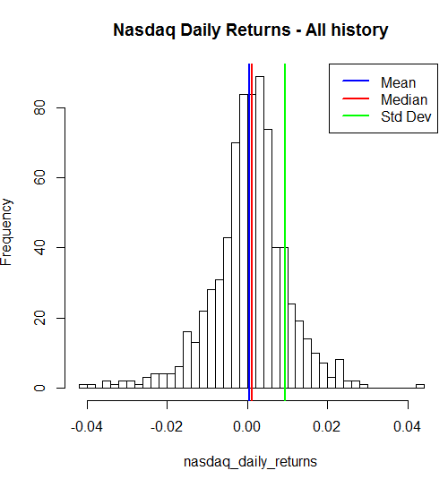

This second histogram has less points, it considers only a year. It resembles less a normal distribution, but again, the mean is to the left of the median (left skew) and we applied the Shapiro-Wil test and it rejected the Normal distribution at the 95% level of confidence

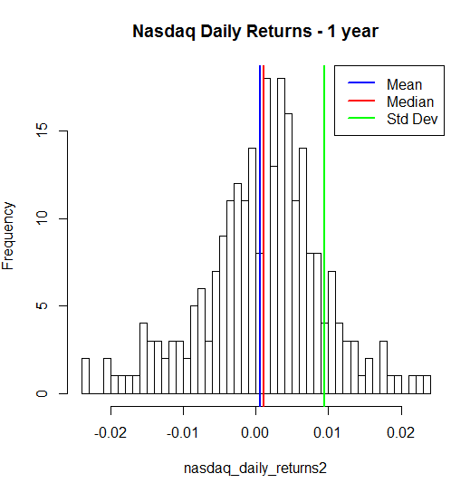

2. Are any obvious trends visible in movement of NASDAQ prices for the period under study?

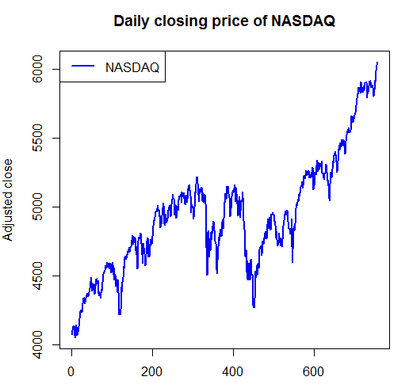

In the period studied we had the Nasdaq in an uptrend move. But that was not an easy ride! From day 200th to 600th the path was more like a roller-coaster than an uptrend. It is important to notice that in the long term all indexes are in a uptrend (maybe except for Cuba or North Korea if there is a exchange in these countries. We need to reject the apocalypse also). 2 or 3 years are in fact a low historic. But we can identify a uptrend.

1. Analyze the measures of central tendency calculated and offer opinion on the overall risks and possible rewards associated with investing in the NASDAQ index for the period under study.

In our analysis, we could observe a mean < median. That period was a great time to be invested in the index, at least in an absolute return perspective. To be protected against the negative outliers days which contributes to make the mean < median, one could buy otm puts along with the index (long Nasdaq index, long Nasdaq put options).

As a matter of fact, most indexes are left skewed and this strategy is not new.

We can not assume that prices follow a normal distribution to consider if we will invest or not in the index. Nicolas Nassim Taleb made his “retirement” in 1987 betting against the Normal distribution premise present in the Black-Scholes model and so buying puts. He advocates in his books that prices follow a Mandelbrot distribution. The normal distribution was reject in the Shapiro-Wilk test that was performed twice (once considering all the downloaded history and other time considering 1 year - 252 days).